EXPLORE THE WORLD WITH SHEAFE’S FLAT BLUEBIRD
Due: Friday, January 13, 2012
STUDENT NAME: ________________________________________________ ROOM ________________

As I leave my penguin friends the “Little Blue Penguin” and “Macaroni Penguin” in Australia, I am flying to the most southern part of the world - ANTARCTICA!
Here are some facts I want to share with you about Antarctica:
Antarctica is the icy continent at the South Pole. Antarctica means “opposite to the Arctic” which is at the North Pole.
Antarctica is the highest, driest, windiest, emptiest, coldest place on earth.
Antarctica is covered by permafrost which is permanently frozen ground. 98% of the land is covered with a continental ice sheet; the other 2% of land is barren rock. The ice holds 70% of all the fresh water on Earth.
Antarctica is technically the world’s largest desert because most of Antarctica gets less than 2 inches of snow a year. There is so much snow here because it never melts!
The lowest temperature on Earth was recorded in Antarctica: 128.5 degrees below zero. Now that is cold! That is so cold that if you drop a steel bar, it will shatter!
Antarctica is surrounded by the Southern Ocean. Up until the spring of 2000, there were only 4 named oceans (Atlantic, Pacific, Indian, Arctic).
Look at the map below. Color Antarctica white and the surrounding water blue.
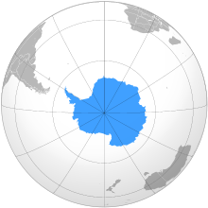
Here’s a riddle for you! Q: Who's the penguin's favorite Aunt? Answer is on the back. ☺

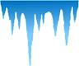

Look at the map below and name the three oceans that the Southern Ocean connects. (The Arctic Ocean is at the North Pole.)
______________________ ______________________ ______________________

Which 3 continents are Antarctica’s neighbors?
______________________ ______________________ ______________________
Riddle answer: Aunt-arctica .

